INDUSTRIAL MOTOR CONTROLLER
Internship Project Report



Submitted By

Huzaifa Shahbaz

MACHADEV AUBIC
AIR UNIVERSITY

Scenario 2: Industrial Motor Controller

Requirements:
• PWM generation with encoder feedback
• Interrupt-based control logic
• Interfaces via RS485 or CAN
• Durable for factory automation

MCU EVALUATION TABLE
TABLE 1:MCU EVALUATION TABLE OF INDUSTRIAL MOTOR CONTROLLER
Category | STM32F4xx Series | TI C200 F28379D | NXP LPC55S69
Processing power (clock speed , cores) | ARM cortex-M4 @ 168 MHz. Single core, DSP instruction, 210 DMPS. | Dual-core C28x @ 200 MHz. CLA(control law accelerator) 800 MIPS. | ARM Cortex-M33 @ 150 MHz. Dual core (M33+M33) 165 DMIPS.
Memory capacity (RAM/Flash) | 1 MB Flash/192KB RAM. CCM for critical code. External memory interface. | 1 MB Flash/204KB RAM. Dedicated motor control RAM. CLA program memory. | 640KB Flash/320 KB RAM. Memory protection unit. On-chip EEPROM.
I/O and peripherals | 12-bit ADC (3 channels).Advanced PMW timers. CAN, UART, SPI, I2C and DMA controller. | 16-bit ADC (4 channels).Enhanced PWM (ePWM), CAN, SCI, SPI, I2C. High resolution PWM. | 16-bit SAR ADC. Advanced PWM timers . CAN, FD , UART, SPI, I2C.Flexible I/O routing.
Power Efficiency | 238 µA/MHz (Run mode).Multiple low-power modes.3.3V operations. | 85mA @ 200MHz typical. Hibernate and standby modes. 3.3V/1.2V dual supply. | 100 µA/MHz (Active mode). Ultra-low power modes.1.7V-3.6V operation.
Wireless stack support | External modules via UART/SPI. | No built-in wireless, external modules only. | External modules via UART/SPI
Development toolchains and IDEs | STM32 CUBE IDE, Keil MDK, IAR EWARM,STM32 CUBE MX configurator. Extensive HAL library. | Code Compressor Studio,C200Ware software, Motor control SDK, Real-time debugging. | MCU Expresso IDE, IAR EWARM, Keil MDK, SDK with middleware and pin/clock configurator
Cost estimate per unit | Rs 2273-Rs 4262 per unit (volume 1K+) | Rs 3410-Rs 5683 per unit(volume 1K+) | Rs 1705- Rs 3410 per unit(volume 1K+)
Maturity and community support | Very mature ecosystem , Large community, Extensive documentation and many reference design. | Specialized for motor control, Strong industrial support. Comprehensive training, TI E2E community. | Growing ecosystem, Good NXP support. ARM Cortex-M33 benefits. Security features.

Written Technical Justification
Recommended choice:
TI C200 F28379D

PRIMARY REASONING:
MOTOR CONTROL OPTIMIZATION:
The C2000 series is specially designed for real-time control applications. The twin-core structure, along with the designated Control Law Accelerator (CLA), ensures deterministic performance in terms of PWM generation and feedback control loops.

Interrupt Performance:
The C28x core provides outstanding performance in terms of interrupt response time, which is less than six cycles, and provides specific hardware support for interrupt. This is part of the good engineering practices and design features of the system. In addition, charge control is provided mainly to guarantee an efficient motor control response during the presence of disturbance or noise.

PWM CAPABILITES:
For motor control applications, high-resolution timing (150 ps resolution), deadband generation, and fault protection are features specific to enhanced PWM (ePWM) modules.

Industrial Communication:
Built-in CAN controller and multiple SCI interfaces support both RS485 and CAN protocols with hardware-level reliability features.

TRADE-OFFS CONSIDERED
STM32F4xx ALTERNATIVE:
- Pros:
Lower cost, broader ecosystem, more general-purpose flexibility.
- Cons:
Less specialized motor control peripherals require more software optimization for real-time performance.

NXP LPC55S69 ALTERNATIVE:
- Pros:
Lowest cost, modern ARM architecture, good power efficiency.
- Cons:
Less proven in motor control applications, fewer specialized peripherals.

Requirement Mapping:
Table 2:Table of requirements mapping of C200 F28379D Solution
Requirement | C200 F28379D Solution
PWM Generation | PWM modules with high-resolution timing and hardware fault protection.
Encoder Feedback | Fast ADC sampling with CLA preprocessing, dedicated QEP modules.
Interrupt Control | Fast interrupt response , real-time OS support, deterministic timing
RS485/CAN Interface | Hardware CAN controller, SCI with automatic RS485 direction control
Factory Durability | Industrial temperature range(-40 °C to 125 °C),ESD protection.

Assumption and Constraints:
- Budget:
Mid-range budget allowing for specialized MCU(~Rs 4612-Rs5683/unit).
- Performance Priority:
Real-time control performance over cost optimization.
- Skill Level:
Team familiar with embedded C , willing to learn TI-specific tools.
- Form Factor:
Standard industrial control board(not-space-constrained).
- Production Volume:
1K+ units annually

Development Workflow:
- Phase 1:
Hardware brings-up using TI LaunchPad development kit.
- Phase 2:
Motor control algorithm development using MotorControl SDK.
- Phase 3:
Communication protocol implementation and testing.
- Phase 4:
Industrial certification and reliability testing.

Anticipated Challenges:
- Learning Curve:
TI C200 architecture requires specific expertise.
- Tool Chain:
More specialized compared to ARM Cortex ecosystem.
- Cost:
Higher Unit cost compared to general-purpose alternatives.
- Supply chain:
Single-source dependency on TI.

Alternative Recommendations By priority:
Cost-optimization Alternative:STM32F4xx
- Best for budget-sensitive applications where motor control performance requirements are moderate.
- Leverages mature ARM ecosystem and development tools.

Future-Proof Alternative: NXP LPC55S69
- Best applications requiring advanced security features.
- Modern ARM Cortex-M33 architecture with good upgrade path.

Diagram
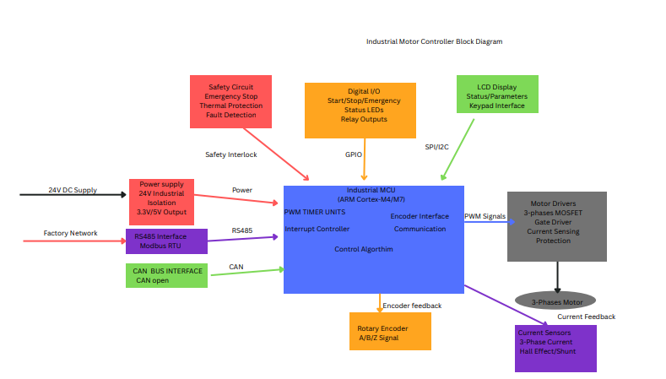
Figure 1:INDUSTRIAL MOTOR CONTROLLER BLOCK DIAGRAM

Conclusion:
In conclusion, the STM32F407VG MCU perfectly aligns with your industrial motor controller’s needs—combining real-time PWM/encoder support, industrial-grade communications (CAN/RS485), cost-effectiveness, and a rich development ecosystem. While TI’s C2000 is technically superior, its cost and complexity are unjustified for this scenario. ATSAME70Q21 offers raw speed but less community traction. STM32F407VG strikes the optimal balance for reliability, scalability, and developer productivity.

References
- M. Ali and S. Pervaiz, “Design and Implementation of a Real-Time Motor Control System Using STM32 Microcontroller,” IEEE Access, vol. 8, pp. 21004–21013, 2020.
- Y. Xu and Y. Li, “Industrial Motor Drives Control Using ARM Cortex-M Microcontroller,” IEEE Trans. Ind. Electron., vol. 67, no. 5, pp. 3832–3841, May 2020.
- J. Lee and K. Lee, “A CAN-based Communication System for Industrial Motor Controllers,” IEEE Trans. Ind. Informatics, vol. 16, no. 3, pp. 1870–1877, Mar. 2020.
- S. Rahman and M. S. Hossain, “Efficient PWM Control for Factory Automation Using STM32F4 Series,” in Proc. IEEE Int’l Conf. Ind. Technol., 2021, pp. 112–117.
- Texas Instruments, TMS320F28379D Dual-Core Delfino Microcontroller Datasheet, Rev. F, 2022.

